**Participant Consent Form for Action Research Project**

Researcher: Kim Noce

**Project Title:** " How can student self-evaluation impact critical thinking, anxiety,

and compassion among students of diverse background, ability and needs to bridge inclusive gaps?”

**Purpose of the Research:** This research aims to explore the impacts of self-evaluation on critical thinking, anxiety, and compassion among students in higher education.

**What Will You Be Asked to Do**: You may be asked to participate in self-evaluation activities, complete a questionnaire, and possibly take part in a focus group. Participation is completely voluntary.

**Data Storage:** Your data will be stored securely and will only be accessible by the research team. Anonymity will be maintained by assigning code numbers to participants.  
  
**Quoting and Referencing Preferences**: This section helps us understand how you would like to be referenced if your contributions are directly quoted or discussed in the research findings. By providing your preference, you help us respect your wishes in how your contributions are represented in this research. Your choice here will not affect your participation in the study.

Please indicate your preference:

* I prefer to remain anonymous in any publication or presentation resulting from this study.
* I would like to be attributed by my role (e.g., student, staff).
* I consent to being attributed by name in any publication or presentation resulting from this study.
* Other, please specify: _______________________________________________________________________

**Optional: Disabilities** This section is entirely optional. Your participation in this study will not be affected if you choose not to answer this part. We aim to make this study as accessible as possible for all participants. By providing this information, you help us make the necessary arrangements to accommodate all participants in the study. Your information will be kept strictly confidential. If you have a disability that we should be aware of to accommodate you during this study, please indicate below:

* I prefer not to say.
* I have a mobility impairment and may require an accessible location for in-person activities.
* I have a hearing impairment and may require captioning or sign language interpretation.
* I have a visual impairment and may require materials in alternative formats (e.g., large print, Braille, audio).
* Other, please specify: _______________________________________________________________________

**Consent:** I have read and understood the purpose and nature of this study and I agree to participate. Tick all that apply.

* **I consent to participate in this study**
* **I consent to my image or voice being recorded**
* **I wish to participate anonymously**

**Right to Withdraw:** You have the right to withdraw from this study at any point without any repercussions.

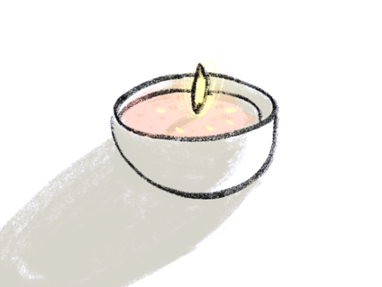Signature: ________________________________________________________________

Participant's Name (or code for anonymity) _____________________________________

Date _____________________________________________________________________