Interdisciplinary Animation

in Pedagogy

**Kim Noce 22047923** FORMATIVE ASSESSMENT RMM 18 February 2024

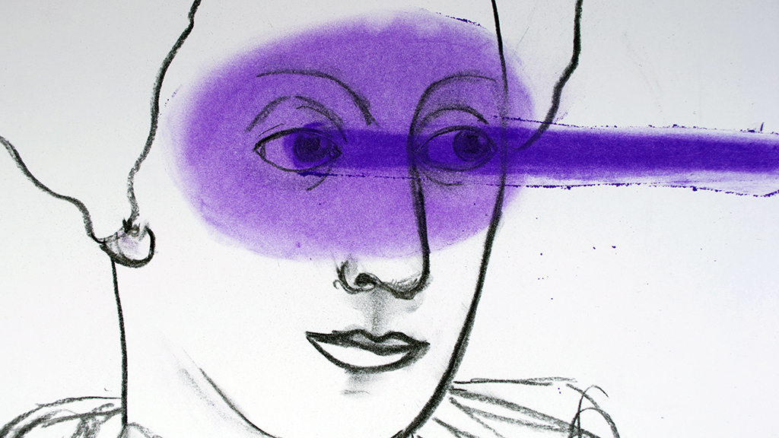

Figure 1 Image Love in Idleness (2017) Kim Noce

# [First Ideas](https://kimnoce.myblog.arts.ac.uk/2024/02/17/map-first-tutorial-with-john/)

Discussed with J. O’Reilly on 30 January during the tutorial

I aim to explore the impactful career of Jo Ann Kaplan, a British filmmaker and artist renowned for her pioneering work in experimental films and animation. Born in 1945, Kaplan’s artistry uniquely fused animation with live action, addressing a myriad of themes that have profoundly influenced the experimental film domain. The UAL Jo Ann Kaplan Archive, which I mention, is a treasure trove of her works and personal effects, pending cataloguing but available upon request. I propose several research ideas aimed at incorporating Kaplan’s techniques into educational strategies. These include leveraging her storytelling methods, interdisciplinary approaches, and archival research for pedagogical innovation, showcasing her enduring influence on educational practices and research methodologies. **Read more**[**here**](https://kimnoce.myblog.arts.ac.uk/2024/02/17/map-first-tutorial-with-john/)

## Development

“How can Jo Ann Kaplan’s use of personal narratives in her films/animation and her interdisciplinary approach to integrating various artistic mediums inform and enhance pedagogical methods to encourage student self-expression, critical thinking, and engagement across disciplines in art education?”

The project I propose merges the exploration of personal narratives in art education with the development of interdisciplinary teaching methods, inspired by Jo Ann Kaplan’s work. By focusing on Kaplan’s utilisation of personal storytelling in her films, this research will delve into how personal narratives can serve as a powerful pedagogical tool to foster self-expression and critical thinking among students. Simultaneously, it will examine Kaplan’s eclectic integration of various artistic mediums—spanning visual arts, film, literature, animation and psychoanalysis—to inspire innovative interdisciplinary teaching strategies. This dual approach aims to leverage the depth and breadth of Kaplan’s artistic endeavours, proposing a comprehensive pedagogical framework that not only encourages students to explore their own narratives but also to appreciate and engage with a wide array of disciplines, reflecting the rich, multifaceted nature of Kaplan’s artistic legacy.

# Positionality

(725 words)

Positioning myself within the field of experimental film and animation, my practice bridges the gap between historical legacies and contemporary pedagogical. My focus on Jo Ann Kaplan’s work, as a filmmaker, animator and artist renowned for her experimental approaches, allows me to explore interdisciplinary methodologies that enhance educational strategies. As a course leader for MA Animation at LCC with access to the UAL Jo Ann Kaplan Archive, my position is advantageous. As a practitioner I bring a blend of synergetic, multimodal, and mixed-media making practices aimed at creating empathic, interactive, and immersive experiences. My work embodies a deep commitment to the gift economy, ecology, service orientation, understanding others, developing others, leveraging diversity, and political awareness.

The exploration of Kaplan’s career, specifically her use of personal narratives and interdisciplinary approaches, informs my proposed research. By integrating her storytelling methods and artistic mediums into pedagogy, I aim to foster an educational environment where self-expression, critical thinking, and cross-disciplinary engagement thrive. This approach not only pays homage to Kaplan’s legacy but also explore the boundaries of diverse teaching methods, ensuring her impact extends into future generations of artists and educators.

My personal practice as a filmmaker and animator, characterized by the creation of empathic, interactive, and immersive experiences, directly aligns  and was informed directly by the ethos of Kaplan’s work through her teaching at the NFTS during my graduation film. My engagement in projects such as the immersive animation documentary trilogy “Cities of Ladies” and the interactive AR animated documentary “UNRAVEL” exemplifies the synthesis of innovative storytelling and technology, mirroring Kaplan’s pioneering spirit. These projects, alongside my work on independent films that have garnered international recognition, reflect a commitment to pushing the boundaries of the medium and exploring new narrative forms.

As a maker and enabler in art, illustrations, animation, film, immersive events, and engagement through training, workshops, lectures, masterclasses, research, residencies, and participatory activities, I position myself at the intersection of creativity and education. This stance is further enriched by my background as an immigrant of Italian and Irish descent with Roma heritage, my journey through academia as a late-diagnosed neurodivergent individual, and my professional experiences across a wide spectrum of creative and educational settings to engage aspect of equity and social justice in pedagogy.

Drawing on my diverse experiences, including directing and animating independent short films, co-creating immersive multimedia performances, and leading innovative educational programs, I view my practice through the lens of inclusion and diversity. My work is informed by an awareness of unconscious bias and a commitment to social justice, as reflected in the educational strategies I employ. By decoupling major projects from graded assessments, I encourage intellectual freedom and exploration, fostering an environment where students can engage with their subjects deeply and authentically.

My engagement with the Jo Ann Kaplan Archive and the development of research projects that utilize her techniques and approaches is not just an academic endeavor but a personal journey. It reflects my belief in the power of storytelling, interdisciplinary collaboration, the transformative potential of education and a homage to one of my own teachers. My positionality, influenced by my cultural heritage, professional background, and personal experiences, drives my commitment to creating a more inclusive, empathetic, and engaging learning environment.

As the field of experimental film and animation continues to evolve, my work aims to contribute to this dynamic landscape by highlighting the importance of historical legacies like Kaplan’s, while advocating for pedagogical innovations that embrace diversity, creativity, and critical thinking. By situating myself within this interdisciplinary field, I bring a perspective that combines a respect for tradition with a passion for innovation, aiming to inspire future generations of artists, educators, and researchers. In conclusion, my positioning within the field of practice is rooted in a deep appreciation for the pioneering work of Jo Ann Kaplan as an ex student and colleague, a commitment to exploring pedagogy methods, and a personal and professional journey marked by diversity, resilience, and creativity. My research and practice aim to not only explore and extend Kaplan’s artistic legacy but also to challenge and transform educational paradigms, ensuring that the field remains vibrant, inclusive, and responsive to the complexities of contemporary society. Through this work, I bring a unique contribution to the table, one that bridges historical legacies with future possibilities, fostering an environment where experimental film and animation can continue to flourish and inspire.

# Annotated Bibliography

**Bell, Judith (2010) Doing Your Research Project,**McGraw-Hill Education, McGraw-Hill Education ProQuest Ebook Central, <http://ebookcentral.proquest.com/lib/ual/detail.action?docID=771407.> Created from UAL on 2023-02-18 10:22:10.

(253 words)  
  
In her seminal work, Judith Bell provides an essential roadmap for conducting research across various disciplines. The chapters on case studies and experimental research are particularly relevant for a project centered on Jo Ann Kaplan, a pioneering figure in experimental film and animation.

Bell elucidates the case study methodology as a profound tool for in-depth analysis, offering a pathway to explore Kaplan’s extensive career and her unique contributions to the film and animation fields. This approach allows for a detailed examination of Kaplan’s techniques, thematic concerns, and the impact of her work on subsequent generations of artists and filmmakers. Bell’s discussion on experimental research methodologies further complements this study by suggesting ways to empirically test the influence of Kaplan’s interdisciplinary approaches on contemporary pedagogical practices. Through experimental designs, researchers can quantitatively measure the effectiveness of integrating Kaplan’s narrative and visual techniques into educational strategies, thereby providing evidence-based recommendations for enhancing art education.

Bell’s guide emphasizes the importance of ethical considerations, the formulation of clear research questions, and the selection of appropriate methodologies tailored to the specific aims of the research. This work serves not only as a foundational text for understanding the nuances of case study and experimental research but also as a practical manual for applying and testing different methodologies in a study of Jo Ann Kaplan’s contributions to experimental film and animation. By following Bell’s guidelines, researchers can explore how to  investigate Kaplan’s legacy and its potential applications in art education, ensuring that the research is methodologically sound and ethically responsible.

**Vilsmaier, U., Faschingeder, G., & Merçon, J. (2020). Methods for inter- and transdisciplinary research and learning based on Paulo Freire**. Journal für Entwicklungspolitik, 36(3), pp. 4-18.

(278 words)

Based on the document “Methods for Inter- and Transdisciplinary Research and Learning Based on Paulo Freire,” this annotated bibliography entry provides a theoretical and methodological foundation for a research project on Jo Ann Kaplan, focusing on her interdisciplinary contributions to film and animation. Vilsmaier, Faschingeder, and Mercon outline a various approach to research and learning that draws on Freire’s pedagogical theories, emphasizing dialogue, critical reflection, and praxis. This framework supports an exploration of Kaplan’s work within an interdisciplinary context, highlighting the potential for transformative educational practices inspired by her innovative storytelling and visual techniques.

The text advocates for a research methodology that bridges disciplines and engages with complex societal issues through collaborative and participatory processes. This approach is particularly relevant for examining Kaplan’s influence on pedagogy and creative practice, suggesting that Freire’s principles can foster a research environment conducive to innovation, cross-disciplinary engagement, and the co-creation of knowledge. The authors discuss various strategies for implementing Freire’s ideas in research, including the development of critical consciousness, the importance of dialogic engagement among researchers and participants, and the role of action in generating transformative insights.

For a project centred on Jo Ann Kaplan, this document offers valuable insights into how inter- and transdisciplinary research methods can illuminate the depth and impact of her work. It provides a framework for investigating how Kaplan’s interdisciplinary approaches to film and animation can inform and enhance pedagogical methods, encouraging student self-expression, critical thinking, and engagement across disciplines. The emphasis on participatory research and learning aligns with Kaplan’s legacy of pushing the boundaries of traditional film and animation, making this text a crucial resource for understanding the implications of her work for contemporary educational practices.

## Other Texts

* KAPLAN, A., 2011. Play It As It Lays. The New Soundtrack, **1**(2), pp. 177-180.
* O’DONOGHUE, D., 2023. Maya Deren: Choreographed for Camera. Cineaste, **48**(4), pp. 75. <https://www.proquest.com/magazines/maya-deren-choreographed-camera/docview/2860870351/se-2?accountid=10342>
* ‘A concise portrait of Maya Deren’ (2011) Art Newspaper, (230), p. 42. Available at: <https://search-ebscohost-com.arts.idm.oclc.org/login.aspx?direct=true&db=aft&AN=527634159&site=ehost-live&scope=site>(Accessed: 18 February 2024).