

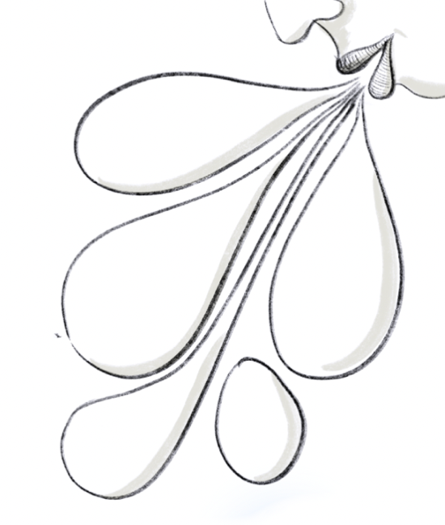Research project: Growing Equity

**Participant Information Sheet**

**About this study**

This study is part of my research on the PgCert Academic Practice in Art, Design and Communication at UAL.

I am conducting an inquiry into how student self-evaluation impacts critical thinking, anxiety, and compassion. I am interested in the experiences, expectations, and reflections of students and staff at UAL concerning self-evaluation tasks in their first year of study.

My research will document, evaluate, and analyse the self-evaluation process in higher education. The methodology will be qualitative: taking a responsive evaluation approach. This will consist of a questionnaire and an in-depth focus group with students and staff. Responses will be analysed thematically, qualitative and quantitative.

**What does it mean to take part?**

If you take part, you are consenting to participate in a survey questionnaire that may take approximately 15-30 minutes. I will record the survey as a mentimenter pdf it for academic analysis.

If you take part, you are consenting to participate in a focus group that may take approximately 45-60 minutes. I will audio record the focus group and transcribe it, and I will take picture of the discussion for academic analysis.

If you take part, you are consenting to participate in the field notes that may take approximately 45-60 minutes. I will sketch you in the field notes and write few words you mention and collect them as photograph it for academic analysis.

If you choose to take part, you will be free to withdraw your participation at any point. You will not be obliged to give any reason for deciding not to take part.

**Will my participation be kept confidential?**

Your anonymity is very important. The information about you will be confidential to me, as the researcher. You will not be identified individually anywhere in the research. If I quote anything you have said in an interview, it will be anonymous, such as "Participant A noted, 'The process is...'."

**What will happen to the results of the research project?**

Analysis from the survey questionnaire, focus group and fields notes - including quotations from you and photographs and drawing of the event – will contribute to an academic dissertation. Your words may also be used in academic reports, papers, or conference presentations, and these may appear online.

Thank you for your contribution and participation in this study.

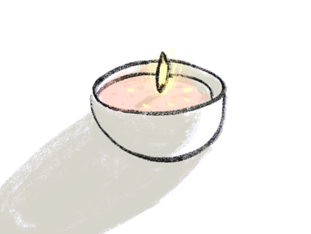

**Contact for further information:**

Kim Noce, Investigator

[k.noce@lcc.arts.ac.uk](mailto:k.noce@lcc.arts.ac.uk)